**HTML Elements**

The **HTML** element is everything from the **start** **tag** to the **end** **tag**:

<tagname>Content goes here...</tagname>

You can usually modify the default, like:

<hr size=”3”>

There are also self-closing tags (see list below).

1. [<area>](https://www.tutorialstonight.com/html-tags-list-with-examples#area) - HTML area tag defines an area in an image based on coordinates which then accepts an URL and becomes a clickable area behaving like a hyperlink
2. <base> - It defines the base URL for all the relative URLs in the document
3. [<br>](https://www.tutorialstonight.com/html-tags-list-with-examples#br) - *br* is used to create a line break
4. [<col>](https://www.tutorialstonight.com/html-tags-list-with-examples#col) - It defines a column in a table to define a common style or property of that column
5. <embed> - It is used to embed external content on the webpage
6. [<hr>](https://www.tutorialstonight.com/html-tags-list-with-examples#hr) - It creates a horizontal line
7. [<img>](https://www.tutorialstonight.com/html-tags-list-with-examples#img) - It is used to define an image
8. [<input>](https://www.tutorialstonight.com/html-tags-list-with-examples#input) - It is used to create an input field
9. [<link>](https://www.tutorialstonight.com/html-tags-list-with-examples#link) - It is mostly used to add external stylesheets to the HTML document
10. [<meta>](https://www.tutorialstonight.com/html/html-meta-tag) - It is used to give metadata to the webpage
11. <param> - It defines parameter to the object
12. [<source>](https://www.tutorialstonight.com/html-tags-list-with-examples#source) - It is used to give multiple media of resources for audio, video, and pictures
13. [<track>](https://www.tutorialstonight.com/html-tags-list-with-examples#track) - It is used in media files to provide times text tracks
14. <wbr> - It provides a word break position in a paragraph for the browsers

**HTML Attribute**

HTML attributes provide additional information about HTML elements.

* All HTML elements can have **attributes**
* Attributes provide **additional information** about elements
* Attributes are always specified in **the start tag**
* Attributes usually come in name/value pairs like: **name="value"**

For example, the line below has 3 attributes:

* Scr – specifies the path to the image
* Width – specifies the width of the image (in pixels)
* Height – specifies the height of the image (in pixels)

<img src="img_girl.jpg" width="500" height="600">

**HTML Boilerplate**

A **boilerplate** in **HTML** is a template you will add at the start of your project. You should add this boilerplate to all of your **HTML** pages. Shortcut to basic HTML Boilerplate: **Type “!” + Tab.**

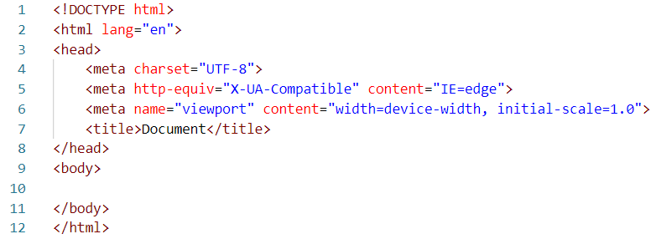

* **Doctype in HTML -** The first line in your HTML code should be the doctype declaration. A doctype tells the browser what version of HTML the page is written in. If you forget to include this line of code in your file, then some of the HTML 5 tags like <article> < footer>, and <header> may not be supported by the browser.
* **HTML root element -** The <html> tag is the top level element of the HTML file. You will nest the <head> and <body> tags inside of it. The <lang> attribute inside the opening <html> tag sets the language for the page. It is also good to include it for accessibility reasons (screen readers will know how to properly pronounce the text).
* **Head tags in HTML -** The <head> tags contain information that is processed by machines. Inside the <head> tags, you will nest metadata which is data that describes the document to the machine.
* **UTF-8 character encoding** - UTF-8 is the standard character encoding you should use in your web pages. This will usually be the first <meta> tag shown in the <head> element.
* **Viewport meta tag in HTML** - This tag renders the width of the page to the width of the device's screen size. If you have a mobile device that is 600px wide, then the browser window will also be 600px wide. The initial-scale controls the zoom level. The value of 1 for the initial-scale prevents the default zoom by browsers.
* **X-UA-Compatible** - This <meta> tag specifies the document mode for Internet Explorer. IE=edge is the highest supported mode.
* **HTML title tags** -The <title> tag is the title for the web page. This text is shown in the browser's title bar.

**Structuring Text in HTML**

* **Prettier** is an extension in VS Code that allows to format your code with a generally accepted style.
* After installing Prettier, use shortcut **Shift + Alt + F** to format the code. Alternatively, you can set it to automatically format it when the file is saved.

**Headings**

* HTML headings are titles or subtitles that you want to display on a webpage.
* HTML headings are defined with the <h1> to <h6> tags.
* <h1> defines the most important heading. <h6> defines the least important heading.

**Note**: Browsers automatically add some white space (a margin) before and after a heading.

**Note:** Use HTML headings for headings only. Don't use headings to make text **BIG** or **bold**.

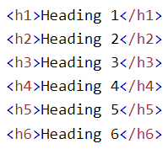 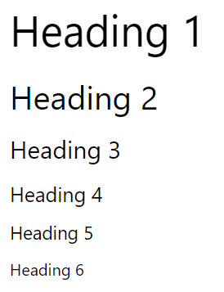

* Search engines use the headings to index the structure and content of your web pages.
* Users often skim a page by its headings. It is important to use headings to show the document structure.
* <h1> headings should be used for main headings, followed by <h2> headings, then the less important <h3>, and so on.
* Each HTML heading has a default size. However, you can specify the size for any heading with the style attribute, using the CSS font-size property:

<h1 style="font-size:60px;">Heading 1</h1>

**Text Most Common Tags**

**<strong>**

element indicates that its contents have strong importance, seriousness, or urgency. Browsers typically render the contents in bold type.

This could be a sentence that is of great importance to the whole page, or you could merely try to point out that some words are of greater importance compared to nearby content.

The <strong> element is for content that is of greater importance, while the <b> element is used to draw attention to text without indicating that it's more important.

**<b>**

Used to draw the reader's attention to the element's contents, which are not otherwise granted special importance.

**<em>**

For words that have a stressed emphasis compared to surrounding text, which is often limited to a word or words of a sentence and affects the meaning of the sentence itself. Typically this element is displayed in italic type. However, it should not be used to apply italic styling.

Don’t confuse <i> with <em>. By default, the visual result is the same. However, the semantic meaning is different. The <em> element represents stress emphasis of its contents, while the <i> element represents text that is set off from the normal prose, such a foreign word, fictional character thoughts, etc.

**< i >**

Used to italize the element’s contents.

**<p>**

Represents a paragraph. Paragraphs are usually represented in visual media as blocks of text separated from adjacent blocks by blank lines and/or first-line indentation, but HTML paragraphs can be any structural grouping of related content, such as images or form fields.

**<br>**

Produces a line break in text.

**<pre>**

Represents preformatted text which is to be presented exactly as written in the HTML file. The text is typically rendered using a non-proportional, or monospaced, font.

**HTML Lists**

**Unordered HTML List**

An unordered list starts with the <ul> tag. Each list item starts with the <li> tag.

The list items will be marked with bullets by default:

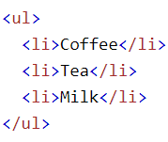 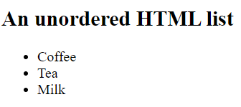

**Ordered HTML List**

An ordered list starts with the <ol> tag. Each list item starts with the <li> tag.

The list items will be marked with numbers by default:

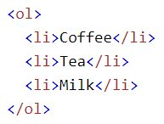 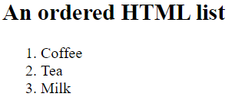

**Note**: Use <ol type=”A”> to display A,B,C… instead of numbers.

**Note**: Use <ol type=”I”> to display Roman Numbers instead of numbers.

**Adding Images**

<img> is a self-closing tag, but it isn’t enough, it needs:

* A source (url from the internet or a local image included in the same directory as the website).
* Alternative text, in case the image can’t be displayed).
* Attributes (Shape, size…).

<img src="Motorcycle.jpg" alt="Image of a Motor cycle" />

**HTML Links and Anchor Tags**

* You can click on a link and jump to another document.
* The HTML <a> tag defines a hyperlink. It has the following syntax:

<a href="*url*">*link text*</a>

* The most important attribute of the <a> element is the href attribute, which indicates the link's destination.

<a href="https://www.w3schools.com/">Visit W3Schools.com!</a>

* A link does not have to be text. A link can be an image or any other HTML element! For example, see below a link to another HTML file named “Contact Details”.

    <h3><a href="Contact Details.html">Contact Details </a></h3>

**HTML Tables**

Main Table Tags:

* <Table> - contains all the table code
* <tr> - Table Row
* <td> - Table Data (corresponds to a table cell)
* <thead> - Contains the table head elements
* <th> - Table Data for headers
* <tbody> - Contains all the table body elements
* <tfoot> - Contains all the table footer elements

*<table>*

*<tr>*

*<th>Company</th>*

*<th>Contact</th>*

*<th>Country</th>*

*</tr>*

*<tr>*

*<td>Alfreds Futterkiste</td>*

*<td>Maria Anders</td>*

*<td>Germany</td>*

*</tr>*

*<tr>*

*<td>Centro comercial Moctezuma</td>*

*<td>Francisco Chang</td>*

*<td>Mexico</td>*

*</tr>*

*</table>*

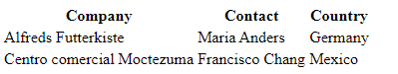

**HTML Forms**

* An HTML form is used to collect user **input**. The user input is most often sent to a server for processing.
* The HTML <form> element is used to create an HTML form for user input:

<form>  
.  
*form elements*  
.  
</form>

The <form> element is a container for different types of input elements, such as: text fields, checkboxes, radio buttons, submit buttons, etc. For example:

Text Example:

<form>  
  <label for="fname">First name:</label><br>  
  <input type="text" id="fname" name="fname"><br>  
  <label for="lname">Last name:</label><br>  
  <input type="text" id="lname" name="lname">  
</form>

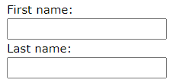

**Radio Buttons**

* The <input type="radio"> defines a radio button.
* Radio buttons let a user select ONE of a limited number of choices.

<p>Choose your favorite Web language:</p>  
  
<form>  
  <input type="radio" id="html" name="fav_language" value="HTML">  
  <label for="html">HTML</label><br>  
  <input type="radio" id="css" name="fav_language" value="CSS">  
  <label for="css">CSS</label><br>  
  <input type="radio" id="javascript" name="fav_language" value="JavaScript">  
  <label for="javascript">JavaScript</label>  
</form>

